TAMAR BRIDGE

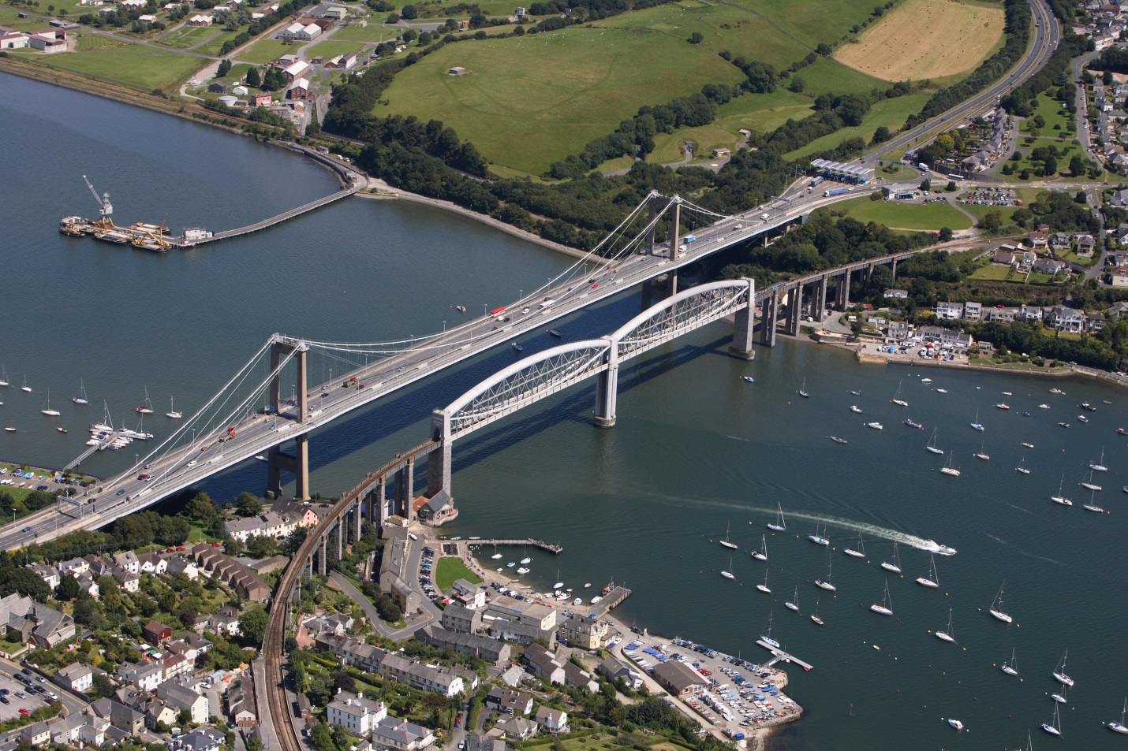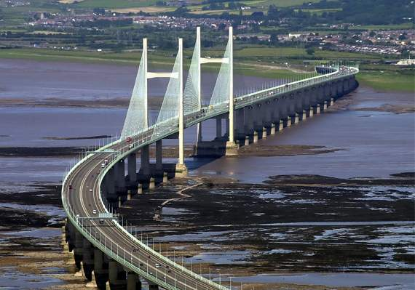Top of Form

The Tamar Bridge is a significant landmark and vital transportation link connecting the counties of Devon and Cornwall in southwest England. Spanning the River Tamar, it serves as a crucial artery for commuters, tourists, and commercial traffic traveling between these two picturesque regions.

Constructed between 1959 and 1961, the Tamar Bridge represents an engineering marvel of its time. Its distinctive suspension design spans approximately 335 meters (1,099 feet), with a main span of 335 meters (1,099 feet). At the time of its completion, it was the longest suspension bridge in the United Kingdom.

The construction of the Tamar Bridge was a complex undertaking, requiring innovative engineering solutions to navigate the challenges posed by the river's strong currents, varying tidal conditions, and the need to accommodate maritime traffic. Engineers employed cutting-edge techniques and materials to ensure the bridge's structural integrity and longevity, setting new standards in bridge construction.

Moreover, the Tamar Bridge has become an integral part of the landscape, offering stunning views of the river and surrounding countryside. Its sleek silhouette and graceful arches stand as a testament to human ingenuity and craftsmanship, inspiring admiration in all who traverse its span.